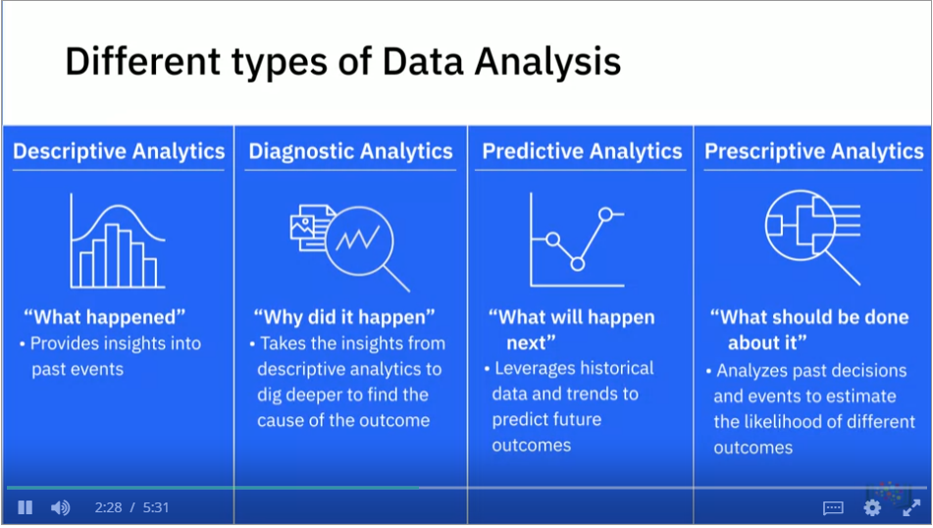

* **Responsibilities of a data analyst**
  + Acquiring Data
  + Creating Queries to extract required data
  + Filtering, cleaning, standardizing and reorganizing data.
  + Using statistical tools., statistical techniques.
  + Analysis patterns
  + Preparing reports and charts
  + Creating appropriate documentation.
* **Technical skills**
  + Spreadsheets
    - Excel
    - Google Sheets
  + Statistical Analysis and Visualization Tools and Software.
    - IBM Cognos, IBM SPSS, Oracle Visual Analyzer, Microsoft Power BI, SAS, and Tableau.
  + Proficiency in programming languages
    - R, Python, C++, Java, and MATLAB
  + Data Bases
    - SQL and NoSQL.
  + Access and Extract Data from Data Repositories
    - Data Marts, Data Warehouses, Data Lakes, and Data Pipelines.
  + Big data processing tools
    - Hadoop, Hive, Spark
* **Functional Skills**
  + Proficient in statistics
    - Analyse data, validate analysis, Identify fallacies, Logical Errors
  + Analytical Skills
    - Research and interpret data, theorize, make forecasts.
  + Problem-Solving Skills
    - Come up with possible solutions to problems
  + Probing skills
    - Identify and define the problem and desired outcome.
  + Data Visualization skills
    - Create clear and compelling visualization to present the analysis.
  + Project Management Skills
    - Manage the process, people, dependencies, and timelines.